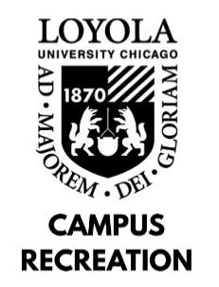

LIFEGUARD JOB DESCRIPTION

Departmental Student Employment Philosophy: As a student employee with Campus Recreation, you will play a vital role in providing recreational and social experiences to the university community. In combination with gaining experience in interpersonal communication and conflict resolution, employment with Campus Recreation will provide you with personal and professional development sessions, leadership opportunities, and comprehensive training programs designed to enhance your self-awareness, sense of community on campus, and critical problem-solving skills.

General Position Description: The Lifeguard staff is responsible for supervision of the Halas Recreation Center pool and aids the Department of Campus Recreation in delivering an enjoyable experience for the Loyola Community. The Lifeguard staff provides excellent customer service to members and guests at the Halas Pool

Minimum Skills and Qualifications:
- Current full time Loyola University Chicago Student
- Current Lifeguard Certification (American Red Cross or Ellis and Associates)
- Ability to communicate using clear, concise, simple language
- Ability to swim 300 meters continuously

Preferred Skills and Qualifications:
- Previous experience in lifeguarding preferred
- Work Study preferred

Job Duties:
- Supervision of the 8 Lane Halas Recreation Center Pool and deck during open recreation and swimming lessons.
- Demonstrate working knowledge of Halas Pool and Campus Recreation rules and regulations; ability and willingness to enforce rules and regulations.
- Coordination of opening/closing procedures, hourly pool counts, and all other daily operations
- Assist in regular cleaning of the Halas Pool and deck area
- Attend bi-weekly Inservice Trainings and remain up to date on all American Red Cross Lifeguard/CPR skills.
- In the event of an emergency, provides emergency care and treatment as required until the arrival of emergency medical services.
Work Location and Environment:
- The majority of work is based on the warm and humid Halas pool deck

Learning Outcomes:
- Identify at least one way in which sense of community on campus has developed.
- Identify at least two ways in which communication skills have developed.
- Identify at least two ways in which problem-solving skills have developed.
- Identify at least one way in which self-awareness has developed.
- Identify at least one way in which leadership skills have developed.

